PROJECT 1
Internet &Web Research
Sevak Ohanesbabrudi
10/7/2013


Over last three decades internet has changed people’s life all over the globe in different ways. Internet users are exposed to billions of web sites and extensive amount of information, which brings the necessity of search engines and effective methods of internet search to our attention.

Table of Contents

Introduction 1
Search Strategy 1
Search Tools 1
Search Engines 1
Standard 2
Meta-search 2
Subject Directories 2
Invisible Web (Database) 3
Discussion Groups 3
Important Search Features 3
Scholarly Research 3
Books Online 3
Images, Maps, and Videos 4
Evaluating the Information You Find 4
Principles of Ethical and Legal Use 4
Intellectual Property 4
Plagiarism 4
Keeping Track of and Citing Resources 5
MLA (with some examples) 5
APA (with some examples) 6
Summary 7
Table of Figures 8
Works Cited 9

Introduction
Over the last three decades internet has had a profound effect on people’s personal and social lives. Using internet and the knowledge of how to search on the web effectively has become a part of common knowledge in the human societies. Considering the large amount of information with a huge range of varieties presented on the internet, learning effective research methods are crucial for internet users. Internet as a virtual space lets everyone freely add or share text, picture, and movie with the rest of the world. Search engine has opened up a new bondless horizon for millions of people. While this has done wonders to build a general-purpose tool for the majority, there are specific things that an individual can do to reveal the secrets hidden beneath the search command line.

Search Strategy
People use internet and search on the web for many different reasons. Regardless of that cause, it is always a good idea to establish search strategies before starting the search. Creating a search strategy always begins with this question: What do I want to do?
1) Browse?
2) Locate a specific piece of information?
3) Retrieve everything I can on the subject?
Answers to these questions will determine how an individual conducts research and what tools he or she will use. For instance, if an individual is browsing and trying to figure out what's available in his or her subject area, he can start out by selecting a subject directory like Yahoo! Then, enter search keyword(s) into one of the meta-search engines, such as Vivisimo , just to see what's out there. Sometimes people are looking for a specific piece of information. In this case, major search engines such as Google or to a specialized database such as Bureau of the Census (for statistics) are the best candidates to use. Also, if a user wants to retrieve all information on a subject, it would be a good idea to try the same search on several search engines. In addition, resources off the Web, such as books, newspapers, journals and other print reference sources may give user a better sense of understanding toward subject and its relevant criteria. (USC Beaufort Library)

Search Tools
The extensive amount of information on the web requires its users to use different means to conduct a successful search on the net, Including search engines, web directories, meta-search tools, web portals and specialty searches.

Search Engines
A search engine is computer software, which is used to locate a specific word, phrase, image, sound or other page or file located on the World Wide Web. Each search engine builds and rebuilds its database through scripts followed by automated web crawling scripts. When using sites or other resources located through a search engine, be sure to record the URL and the date you accessed that resource; you may not be able to replicate the exact same search to reach it again. (Info People)

Standard
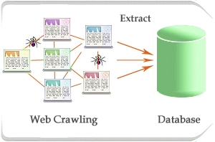
Search engines compile their databases by employing "spiders" or "robots" ("bots") to crawl through web space from link to link, identifying and perusing pages. Sites with no links to other pages may be missed by spiders altogether. Once the spiders get to a web site, they typically index most of the words on the publicly available pages at the site. Web page owners may submit their URLs to search engines for "crawling" and eventual inclusion in their databases.

Figure 1: Web Crawling

2010 | Google | Yahoo! | Bing | Ask | AOL Search | Total
2010-08-28 | 71.59% | 14.28% | 9.87% | 2.28% | 1.21% | 99.23%
2010-07-31 | 71.43% | 14.43% | 9.86% | 2.32% | 1.19% | 99.23%
2010-06-26 | 71.65% | 14.37% | 9.85% | 2.19% | 1.15% | 99.21%
2010-05-22 | 72.00% | 14.58% | 9.20% | 2.18% | 1.06% | 99.02%
2010-05-08 | 71.56% | 14.79% | 9.31% | 2.27% | 1.07% | 99.00%
2010-03-06 | 71.07% | 14.46% | 9.55% | 3.01% | 0.98% | 99.07%
2010-02-06 | 71.35% | 14.60% | 9.56% | 2.55% | 1.06% | 99.12%
2010-01-02 | 72.25% | 14.83% | 8.91% | 2.53% | 0.77% | 99.29%

Meta-search
Meta-search engines do not crawl the web compiling their own searchable databases. Instead, they search the databases of multiple sets of individual search engines simultaneously, from a single site and using the same interface. Meta-searchers provide a quick way of finding out which engines are retrieving the best results for you in your search. (Capital Community College)

Subject Directories
Subject directories, unlike search engines, are created and maintained by human editors, not electronic spiders or robots. The editors review and select sites for inclusion in their directories on the basis of previously determined selection criteria. The resources they list are usually annotated. Directories are smaller than search engine databases, typically indexing only the home page or top level pages of a site. They may include a search engine for searching their own directory or the web, if a directory search is not adequate. (USC Beaufort Library)

Invisible Web (Database)
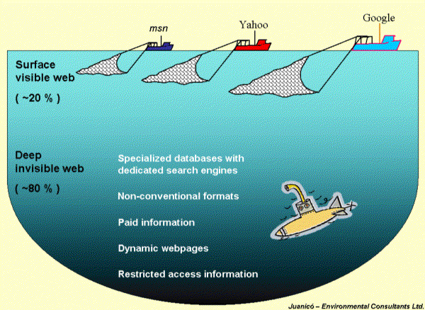
Invisible web also known as deep web refers to those sites which are not visible by regular search engines. Web pages which have lack of keywords or written in other formats can fall in this group. Nowadays, most search engines are searching deeper and deeper that eventually they rich to these pages. Some web search engines automatically eliminate some of these pages because of privacy or primarily that the information in these pages is not public interest. (University of California Berkeley Libraries)
Figure 2: Invisible Web

Discussion Groups
A discussion group is an online setting for individuals to discuss various topics amongst each other. People add their comments by posting a block of text to the group. Others can then comment and respond to those blocks.

Important Search Features
In addition to providing easy access to billions of web pages, search engines have many special features to help you to find exactly what you’re looking for.

Scholarly Research
Searching for scholarly literature is a valuable option that many search engines provide for internet users. Search engines enables their users to search across many disciplines and sources including books, articles, abstracts, theses, from academic publishers, professional societies, online resources, libraries and other web sites.

Books Online
An on-line book is only available to read online. It is a resource in book-like form. On-line book differs from the e-book, which is usually available to download and read locally or on an e-book reader.

Images, Maps, and Videos
Millions of people and organization, and NGOs share and provide online images, videos and maps on the web. People share their videos on the web in YouTube website with others and become famous such as Justin Bibber.

Evaluating the Information You Find
Several things should be considered in evaluation of information including the Purpose, Intended audience, Scope, Currency, Authority, Bibliography, Objectivity and Accuracy of information. (University of Illinois at Chicago)

Principles of Ethical and Legal Use
Unless software, including data, has been placed in the public domain, software is protected by the U.S. Copyright Act. This means that it is illegal to duplicate or distribute software or its documentation without the permission of the copyright owner. Software not copy-protected is not necessarily public domain; it may not be copy-protected so that a legal back-up copy may be made. (Stanford Encyclopedia of Philosophy)

Intellectual Property
Intellectual property (IP) is a legal concept which refers to creations of the mind for which exclusive rights are recognized. Under intellectual property law, owners are granted certain exclusive rights to a variety of intangible assets, such as musical, literary, and artistic works; discoveries and inventions; and words, phrases, symbols, and designs. (WikiPedia)

Plagiarism
Plagiarism is an act or instance of using or closely imitating the language and thoughts of another author without authorization and the representation of that author's work as one's own, as by not crediting the original author. (Dictionary.Reference)

Keeping Track of and Citing Resources

MLA (with some examples)
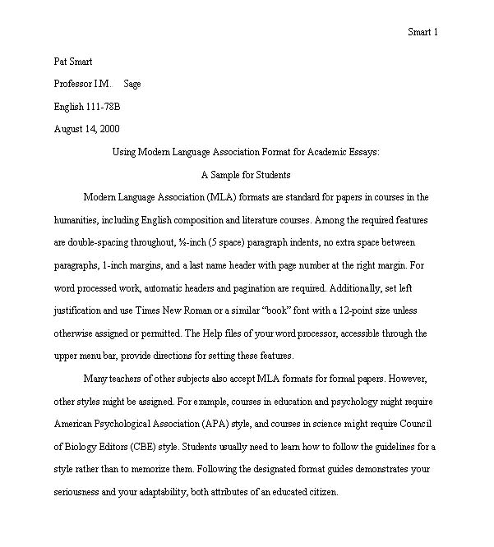
Figure 3: MLA Style Format
MLA stands for Modern Language Association which is a documented style for academic writing mostly in literature and history. This unique writing style lets student and professors to easily keep track of information in an essay, research and articles. It also refers to how to put your resources at the reference page. The example of essay writing is in the following:

APA (with some examples)
APA stands for American Physiological Association is one of the oldest writing styles which are wildly use in social science and business. This style suggests footnotes rather than long explanations in the context to bring more clarity of the subject. The part which is important in APA writing is abstract, which is immediately after title page. Work citing in APA style are organized by surname or it can be a simple URL to the page where we find the information.
Figure 4: APA Style Format
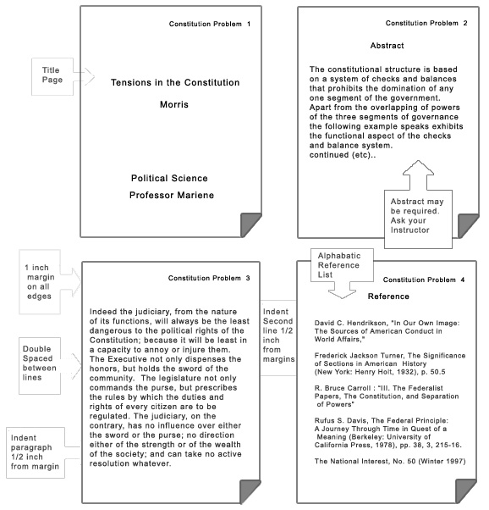

Summary
Although Internet gave us the chance of accessing tremendous database of all kind of information, there is no, or very little, control on the content of web sites which are presented to people. Worthless information as much as valuable information can be presented to the users even though search engines are getting more and more intelligent. We still have to do some logical and systematic effort to evaluate the information that we gathered from the internet. Internet Users should do additional research to evaluate reliability of their sources on the web. Internet users should realize that if they do not respect intellectual property and copy right rules no one will share their information on the web anymore.
It may be a day that doing research in libraries among of thousands of books is meaningless, and students can access all of the books of a library just by pushing some bottoms through internet. Moreover, as well as search engines, there may the web sites which evaluate resources that are presented in the internet.

Table of Figures
Figure 1: Web Crawling 3
Figure 2: Invisible Web 4
Figure 3: MLA Style Format 6
Figure 4: APA Style Format 7

Works Cited
Capital Community College. Materials from electronics, onlibe resources. 2008. 8 10 2013.
Dictionary.Reference. Dictionary.com. 2013. 7 10 2013.
Duke University Libraries. Evaluating web page. 25 sep 2007. 8 10 2013.
Info People. Search Tools. 2012. 26 09 2013.
Stanford Encyclopedia of Philosophy. Interner research ethics. 22 6 2012. 8 10 2013.
University of California Berkeley Libraries. Invisible Web. 8 5 2008. 8 10 2013.
University of Illinois at Chicago. Criteria for Critical Evaluation of Information on the Internet. 30 8 2001. 8 10 2013.
USC Beaufort Library. Creating a Serach Stategy. 2006. 26 09 2013.
WikiPedia. en.Wikipedia. 2010. 7 10 2013.

Captured from Google images
Captured from Wikipedia
Captured from Google images
Non-governmental organizations are legally constituted corporations created by natural or legal people that operate independently from any form of government.
Purdue Owl
Purdue Owl

